“Automotive Challenges: Managing Risk and Improving Our Image”
Featuring:
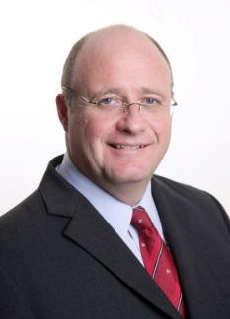
Alistair (Al) R. Deane
Chief Technology and Quality Systems Officer
TI Automotive

“It’s Time to Re-Wire the Automotive Supplier Quality Switch”

Monday June 27, 2016
8:00am - 9:00am - Registration & continental breakfast
9:00am - 5:00pm - Symposium featuring Robert Perkins- “The Joint Journey of Discovery”
Cathy Fisher- “Automotive Quality in the Autonomous Age” and Denis Devos-
“Two New Problem Solving Tools For the Automotive Industry”
Automotive Awards featuring Quality Leader of the Year, Quality Professional
of the Year, Judson P. Jarvis Service Award, William R. Koth Outstanding Service
Award and the Deming Scholarship.

Where:
 | 21400 Oakwood Boulevard  Dearborn, Michigan 48124  Continental Breakfast, Lunch and Afternoon break  Limited Seating  Sponsorship: Silver, Gold and Platinum Levels*  Door Prizes | 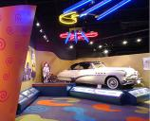
Cost: | $65 ASQ Members; $80 ASQ Non-Members
Registration: | Online at:http://www.eventbrite.com/e/2016-asq-automotive-division-symposium-and-awards-event-tickets-24967304881
RU’s: | Recertification Units: 1.0 RU for all ASQ Certifications  ASQ members can become ASQ Automotive Division members by contacting  ASQ at 1.800.248.1946 ($10 annual division membership fee)
Contacts: | David Butler: davidbutler@us.tiauto.com  *Larry Smith: lrsmith2@peoplepc.com

*Sponsor Details:

Sponsor Levels: | Silver | Gold | Platinum
Sponsorship Cost: | $250 | $500 | $1,000
Sponsorship Benefit:
Complimentary
passes | 1 | 2 | 4
Each exhibitor/sponsor will also be able to display (table/booth) at the event. We will also include the business logo in all of our advertising and in the onsite program. And we will post the sponsors names on the ASQ Automotive Division Website.
To sponsor, please contact Larry Smith lrsmith2@peoplepc.com

